Alberth Matos
07 April 2026
Lab 4 report
CYOP 300 - BUILDING SECURE WEB APPLICATIONS

Executive Summary
Attached is my submission for lab 4. While no particular diﬃculties were encountered, there are a few items that I would like to discuss in my submission.
I split the code base into three sections, a main module containing the top menu, and calling out to a module named matrix_game.py, which contained the majority of the application code.
I split the phone number and zip code input and validation functions, along with a helper function to validate the input using a regex, into its own module. Both get_phone() and get_zipcode() call validate_value(), passing both a string and a regex pattern. validate_value() then returns a Boolean value indicating whether the regex successfully matches the string.
Due to the number of options, and places where user input could impact execution of the program, a number of tests were executed to validate functionality. However, some liberties were taken with skipping input that simply repeated the previous lines of code—namely, entering values for rows 2 and 3 of each matrix. Since the logic that validated each individual row was identical, I felt that separately testing and validating that rows 2 and 3 of both matrixes contained only acceptable integer or floating point values were redundant and unnecessary.
Full unit tests were generated, and are included in the project zip file.
Pylint results are included at the end of this report. I note that pylint run 1 produced erroneous results because I failed to source my python-venv environment prior to running pylint, causing the import errors for NumPy and pandas. This was corrected for my second run.

Testing

Test Case Table
Test Cases | Description | Expected Output | Actual Output | Pass/Fail
Test Case 1 | Invalid Response to play the matrix game: 1 | Invalid input. Please enter Y or N.  Do you want to play the Matrix Game?  Enter Y for Yes or N for No: | Invalid input. Please enter Y or N.  Do you want to play the Matrix Game?  Enter Y for Yes or N for No: | Pass
Test Case 2 | No to play the matrix game: n | Do you want to play the Matrix Game?  Enter Y for Yes or N for No: n  *************** Thanks for playing Python NumPy *************** | Do you want to play the Matrix Game?  Enter Y for Yes or N for No: n  *************** Thanks for playing Python NumPy *************** | Pass
Test Case 3 | Yes to play the matrix game: y | Do you want to play the Matrix Game?  Enter Y for Yes or N for No: y  Enter your phone number (XXX-XXX-XXXX): | Do you want to play the Matrix Game?  Enter Y for Yes or N for No: y  Enter your phone number (XXX-XXX-XXXX): | Pass
Test Case 4 | Invalid phone number format:  Enter 2125551212 | Enter your phone number (XXX-XXX-XXXX): 2125551212  Your phone number is not in correct format. Please re-enter:  Enter your phone number (XXX-XXX-XXXX): | Enter your phone number (XXX-XXX-XXXX): 2125551212  Your phone number is not in correct format. Please re-enter:  Enter your phone number (XXX-XXX-XXXX): | Pass
Test Case 5 | Invalid phone number format:  Enter +12125551212 | Enter your phone number (XXX-XXX-XXXX): +12125551212  Your phone number is not in correct format. Please re-enter: | Enter your phone number (XXX-XXX-XXXX): +12125551212  Your phone number is not in correct format. Please re-enter: | Pass
Test Case 6 | Invalid phone number format:  Enter (212) 555-1212 | Enter your phone number (XXX-XXX-XXXX): (212) 555-1212  Your phone number is not in correct format. Please re-enter:  Enter your phone number (XXX-XXX-XXXX): | Enter your phone number (XXX-XXX-XXXX): (212) 555-1212  Your phone number is not in correct format. Please re-enter:  Enter your phone number (XXX-XXX-XXXX): | Pass
Test Case 7 | Invalid phone:  Enter 212-555-121 | Enter your phone number (XXX-XXX-XXXX): 212-555-121  Your phone number is not in correct format. Please re-enter:  Enter your phone number (XXX-XXX-XXXX): | Enter your phone number (XXX-XXX-XXXX): 212-555-121  Your phone number is not in correct format. Please re-enter:  Enter your phone number (XXX-XXX-XXXX): | Pass
Test Case 8 | Invalid phone:  Enter 212-555-121a | Enter your phone number (XXX-XXX-XXXX): 212-555-121a  Your phone number is not in correct format. Please re-enter:  Enter your phone number (XXX-XXX-XXXX): | Enter your phone number (XXX-XXX-XXXX): 212-555-121a  Your phone number is not in correct format. Please re-enter:  Enter your phone number (XXX-XXX-XXXX): | Pass
Test Case 9 | Valid phone:  Enter 212-555-1212 | Enter your phone number (XXX-XXX-XXXX): 212-555-1212  Phone number accepted: 212-555-1212  Enter your zip code in ZIP+4 format (XXXXX-XXXX): | Enter your phone number (XXX-XXX-XXXX): 212-555-1212  Phone number accepted: 212-555-1212  Enter your zip code in ZIP+4 format (XXXXX-XXXX): | Pass
Test Case 10 | Invalid ZIP+4:  90210 | Enter your zip code in ZIP+4 format (XXXXX-XXXX): 90210  Your zip code is not in correct format. If you do not know your +4 code, please use 0000.  Enter your zip code+4 (XXXXX-XXXX): | Enter your zip code in ZIP+4 format (XXXXX-XXXX): 90210  Your zip code is not in correct format. If you do not know your +4 code, please use 0000.  Enter your zip code+4 (XXXXX-XXXX): | Pass
Test Case 11 | Invalid ZIP+4:  902101234 | Enter your zip code+4 (XXXXX-XXXX): 902101234  Your zip code is not in correct format. If you do not know your +4 code, please use 0000.  Enter your zip code+4 (XXXXX-XXXX): | Enter your zip code+4 (XXXXX-XXXX): 902101234  Your zip code is not in correct format. If you do not know your +4 code, please use 0000.  Enter your zip code+4 (XXXXX-XXXX): | Pass
Test Case 12 | Invalid ZIP+4:  90210-a234 | Enter your zip code+4 (XXXXX-XXXX): 90210-a234  Your zip code is not in correct format. If you do not know your +4 code, please use 0000.  Enter your zip code+4 (XXXXX-XXXX): | Enter your zip code+4 (XXXXX-XXXX): 90210-a234  Your zip code is not in correct format. If you do not know your +4 code, please use 0000.  Enter your zip code+4 (XXXXX-XXXX): | Pass
Test Case 13 | Valid ZIP+4:  90210-1234 | Enter your zip code+4 (XXXXX-XXXX): 90210-1234  Zip code accepted: 90210-1234 | Enter your zip code+4 (XXXXX-XXXX): 90210-1234  Zip code accepted: 90210-1234 | Pass
Test Case 14 | Invalid first matrix row:  1 2 3 4 | Enter row 1 for first: 1 2 3 4  Invalid input. Please enter 3 numeric values separated by spaces. | Enter row 1 for first: 1 2 3 4  Invalid input. Please enter 3 numeric values separated by spaces. | Pass
Test Case 15 | Invalid first matrix row:  1 2 e | Enter row 1 for first: 1 2 e  Invalid input. Please enter 3 numeric values separated by spaces. | Enter row 1 for first: 1 2 e  Invalid input. Please enter 3 numeric values separated by spaces. | Pass
Test Case 16 | Valid first matrix row with integers:  1 2 3 | Enter your first 3x3 matrix:  Enter row 1 for first: 1 2 3  Enter row 2 for first: | Enter your first 3x3 matrix:  Enter row 1 for first: 1 2 3  Enter row 2 for first: | Pass
Test Case 17 | Valid first matrix row with floats:  1.0 2 3.1415926 | Enter your first 3x3 matrix:  Enter row 1 for first: 1.0 2 3.1415926  Enter row 2 for first: | Enter your first 3x3 matrix:  Enter row 1 for first: 1.0 2 3.1415926  Enter row 2 for first: | Pass
Test Case 18 | Invalid second matrix row:  1 2 3 4 | Enter your second 3x3 matrix:  Enter row 1 for second: 1 2 3 4  Invalid input. Please enter 3 numeric values separated by spaces.  Enter row 1 for second: | Enter your second 3x3 matrix:  Enter row 1 for second: 1 2 3 4  Invalid input. Please enter 3 numeric values separated by spaces.  Enter row 1 for second: | Pass
Test Case 19 | Invalid second matrix row:  1 2 e | Enter row 1 for second: 1 2 e  Invalid input. Please enter 3 numeric values separated by spaces. | Enter row 1 for second: 1 2 e  Invalid input. Please enter 3 numeric values separated by spaces. | Pass
Test Case 20 | Valid second matrix row:  1 2 3 | Enter row 1 for second: 1 2 3  Enter row 2 for second: | Enter row 1 for second: 1 2 3  Enter row 2 for second: | Pass
Test Case 21 | Valid second matrix row:  1.0 2 3.1415926 | Enter your second 3x3 matrix:  Enter row 1 for second: 1.0 2 3.1415926  Enter row 2 for second: | Enter your second 3x3 matrix:  Enter row 1 for second: 1.0 2 3.1415926  Enter row 2 for second: | Pass
Test Case 22 | Matrix Operation: Addition with integers using:  Your first 3x3 matrix is:  1 2 4  4 2 1  3 8 9  Your second 3x3 matrix is:  3 2 1  7 2 5  5 2 1 | You selected Addition. The results are:  4 4 5  11 4 6  8 10 10  The Transpose is:  4 11 8  4 4 10  5 6 10  The row and column mean values of the results are:  Row means: 4.33, 7.00, 9.33  Column means: 7.67, 6.00, 7.00 | Enter your first 3x3 matrix:  Enter row 1 for first: 1 2 4  Enter row 2 for first: 4 2 1  Enter row 3 for first: 3 8 9  Your first 3x3 matrix is:  1 2 4  4 2 1  3 8 9  Enter your second 3x3 matrix:  Enter row 1 for second: 3 2 1  Enter row 2 for second: 7 2 5  Enter row 3 for second: 5 2 1  Your second 3x3 matrix is:  3 2 1  7 2 5  5 2 1  Select a Matrix Operation from the list below:  a. Addition  b. Subtraction  c. Matrix Multiplication  d. Element by element multiplication  Enter your choice (a/b/c/d): a  You selected Addition. The results are:  4 4 5  11 4 6  8 10 10  The Transpose is:  4 11 8  4 4 10  5 6 10  The row and column mean values of the results are:  Row means: 4.33, 7.00, 9.33  Column means: 7.67, 6.00, 7.00 | Pass
Test Case 23 | Matrix Operation: Subtraction with integers using:  Your first 3x3 matrix is:  1 2 4  4 2 1  3 8 9  Your second 3x3 matrix is:  3 2 1  7 2 5  5 2 1 | You selected Subtraction. The results are:  -2 0 3  -3 0 -4  -2 6 8  The Transpose is:  -2 -3 -2  0 0 6  3 -4 8  The row and column mean values of the results are:  Row means: 0.33, -2.33, 4.00  Column means: -2.33, 2.00, 2.33 | You selected Subtraction. The results are:  -2 0 3  -3 0 -4  -2 6 8  The Transpose is:  -2 -3 -2  0 0 6  3 -4 8  The row and column mean values of the results are:  Row means: 0.33, -2.33, 4.00  Column means: -2.33, 2.00, 2.33 | Pass
Test Case 24 | Matrix Operation: Matrix Multiplication with integers using:  Your first 3x3 matrix is:  1 2 4  4 2 1  3 8 9  Your second 3x3 matrix is:  3 2 1  7 2 5  5 2 1 | You selected Matrix Multiplication. The results are:  37 14 15  31 14 15  110 40 52  The Transpose is:  37 31 110  14 14 40  15 15 52  The row and column mean values of the results are:  Row means: 22.00, 20.00, 67.33  Column means: 59.33, 22.67, 27.33 | You selected Matrix Multiplication. The results are:  37 14 15  31 14 15  110 40 52  The Transpose is:  37 31 110  14 14 40  15 15 52  The row and column mean values of the results are:  Row means: 22.00, 20.00, 67.33  Column means: 59.33, 22.67, 27.33 | Pass
Test Case 25 | Matrix Operation: Elemental Multiplication with integers using:  Your first 3x3 matrix is:  1 2 4  4 2 1  3 8 9  Your second 3x3 matrix is:  3 2 1  7 2 5  5 2 1 | You selected Element by Element Multiplication. The results are:  3 4 4  28 4 5  15 16 9  The Transpose is:  3 28 15  4 4 16  4 5 9  The row and column mean values of the results are:  Row means: 3.67, 12.33, 13.33  Column means: 15.33, 8.00, 6.00  Do you want to play the Matrix Game? | You selected Element by Element Multiplication. The results are:  3 4 4  28 4 5  15 16 9  The Transpose is:  3 28 15  4 4 16  4 5 9  The row and column mean values of the results are:  Row means: 3.67, 12.33, 13.33  Column means: 15.33, 8.00, 6.00  Do you want to play the Matrix Game? | Pass
Test Case 26 | Matrix Operation: Addition with floats using:  Your first 3x3 matrix is:  1.0 2.2 4.4123  4.21 2.452 1.101  3.1415926 8.0 9.9  Your second 3x3 matrix is:  3.1415926 2.001 1.0  7.25 2.1 5.0  5.5 2.0 1.111 | You selected Addition. The results are:  4.14 4.20 5.41  11.46 4.55 6.10  8.64 10.00 11.01  The Transpose is:  4.14 11.46 8.64  4.20 4.55 10.00  5.41 6.10 11.01  The row and column mean values of the results are:  Row means: 4.58, 7.37, 9.88  Column means: 8.08, 6.25, 7.51 | You selected Addition. The results are:  4.14 4.20 5.41  11.46 4.55 6.10  8.64 10.00 11.01  The Transpose is:  4.14 11.46 8.64  4.20 4.55 10.00  5.41 6.10 11.01  The row and column mean values of the results are:  Row means: 4.58, 7.37, 9.88  Column means: 8.08, 6.25, 7.51 | Pass
Test Case 27 | Matrix Operation: Subtraction with floats using:  Your first 3x3 matrix is:  1.0 2.2 4.4123  4.21 2.452 1.101  3.1415926 8.0 9.9  Your second 3x3 matrix is:  3.1415926 2.001 1.0  7.25 2.1 5.0  5.5 2.0 1.111 | You selected Subtraction. The results are:  -2.14 0.20 3.41  -3.04 0.35 -3.90  -2.36 6.00 8.79  The Transpose is:  -2.14 -3.04 -2.36  0.20 0.35 6.00  3.41 -3.90 8.79  The row and column mean values of the results are:  Row means: 0.49, -2.20, 4.14  Column means: -2.51, 2.18, 2.77 | You selected Subtraction. The results are:  -2.14 0.20 3.41  -3.04 0.35 -3.90  -2.36 6.00 8.79  The Transpose is:  -2.14 -3.04 -2.36  0.20 0.35 6.00  3.41 -3.90 8.79  The row and column mean values of the results are:  Row means: 0.49, -2.20, 4.14  Column means: -2.51, 2.18, 2.77 | Pass
Test Case 28 | Matrix Operation: Matrix Multiplication with floats using:  Your first 3x3 matrix is:  1.0 2.2 4.4123  4.21 2.452 1.101  3.1415926 8.0 9.9  Your second 3x3 matrix is:  3.1415926 2.001 1.0  7.25 2.1 5.0  5.5 2.0 1.111 | You selected Matrix Multiplication. The results are:  43.36 15.45 16.90  37.06 15.78 17.69  122.32 42.89 54.14  The Transpose is:  43.36 37.06 122.32  15.45 15.78 42.89  16.90 17.69 54.14  The row and column mean values of the results are:  Row means: 25.24, 23.51, 73.12  Column means: 67.58, 24.70, 29.58 | You selected Matrix Multiplication. The results are:  43.36 15.45 16.90  37.06 15.78 17.69  122.32 42.89 54.14  The Transpose is:  43.36 37.06 122.32  15.45 15.78 42.89  16.90 17.69 54.14  The row and column mean values of the results are:  Row means: 25.24, 23.51, 73.12  Column means: 67.58, 24.70, 29.58 | Pass
Test Case 29 | Matrix Operation: Elemental Multiplication with floats using:  Your first 3x3 matrix is:  Your first 3x3 matrix is:  1.0 2.2 4.4123  4.21 2.452 1.101  3.1415926 8.0 9.9  Your second 3x3 matrix is:  3.1415926 2.001 1.0  7.25 2.1 5.0  5.5 2.0 1.111 | You selected Element by Element Multiplication. The results are:  3.14 4.40 4.41  30.52 5.15 5.50  17.28 16.00 11.00  The Transpose is:  3.14 30.52 17.28  4.40 5.15 16.00  4.41 5.50 11.00  The row and column mean values of the results are:  Row means: 3.99, 13.73, 14.76  Column means: 16.98, 8.52, 6.97 | You selected Element by Element Multiplication. The results are:  3.14 4.40 4.41  30.52 5.15 5.50  17.28 16.00 11.00  The Transpose is:  3.14 30.52 17.28  4.40 5.15 16.00  4.41 5.50 11.00  The row and column mean values of the results are:  Row means: 3.99, 13.73, 14.76  Column means: 16.98, 8.52, 6.97 | Pass

Test Case Screenshots

Test Case 1
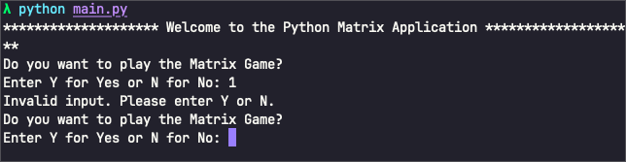

Test Case 2
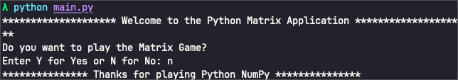

Test Case 3
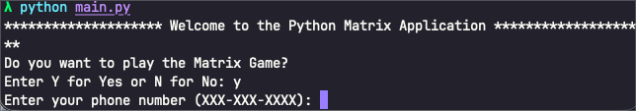

Test Case 4
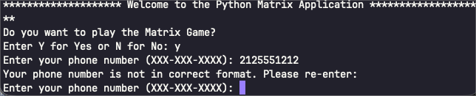

Test Case 5

Test Case 6

Test Case 7

Test Case 8

Test Case 9

Test Case 10
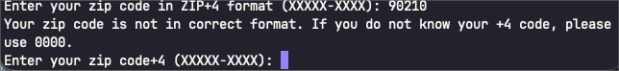

Test Case 11
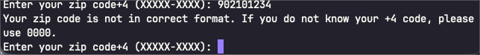

Test Case 12
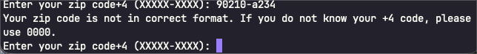

Test Case 13
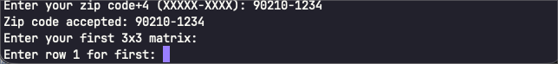

Test Case 14
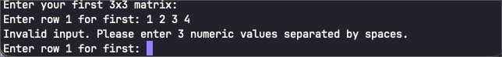

Test Case 15

Test Case 16

Test Case 17

Test Case 18
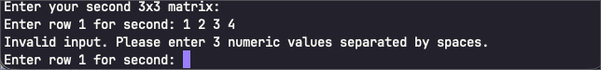

Test Case 19

Test Case 20

Test Case 21

Test Case 22
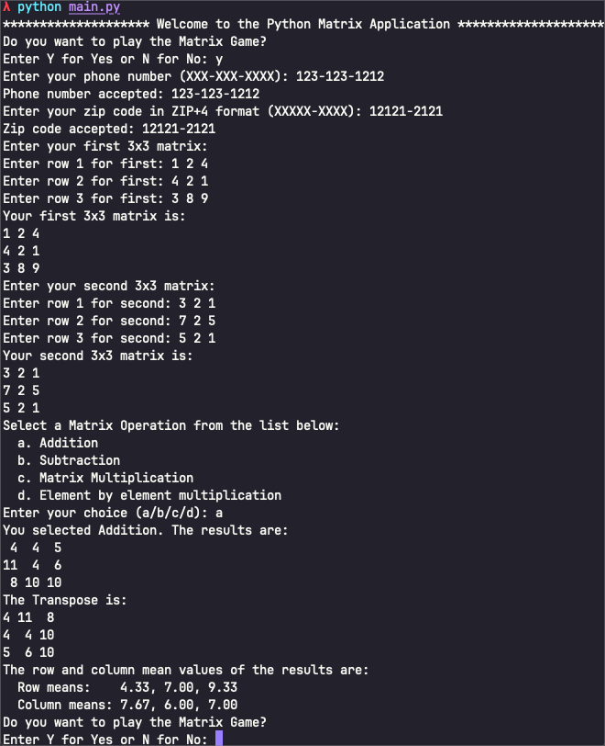

Test Case 23
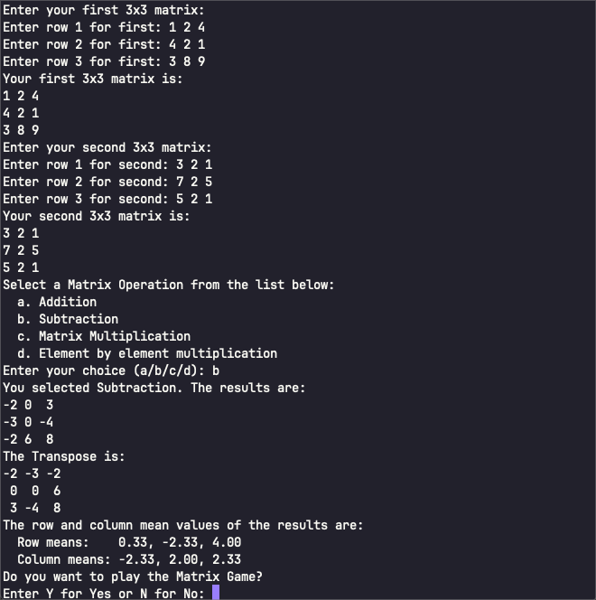

Test Case 24
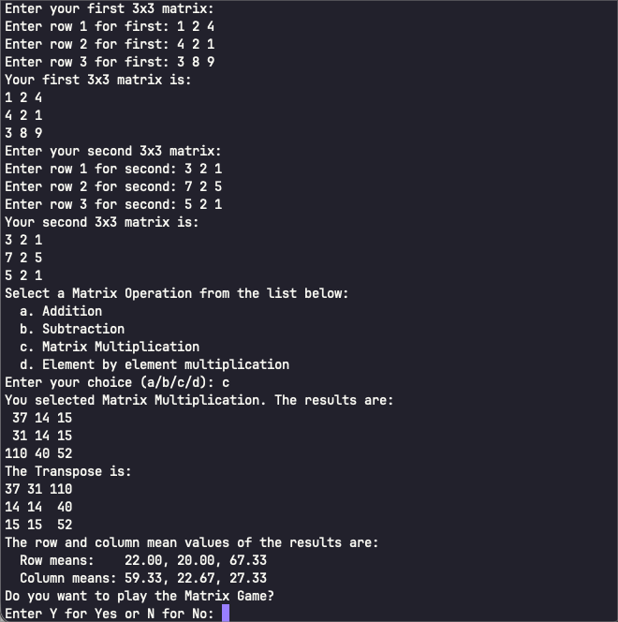

Test Case 25
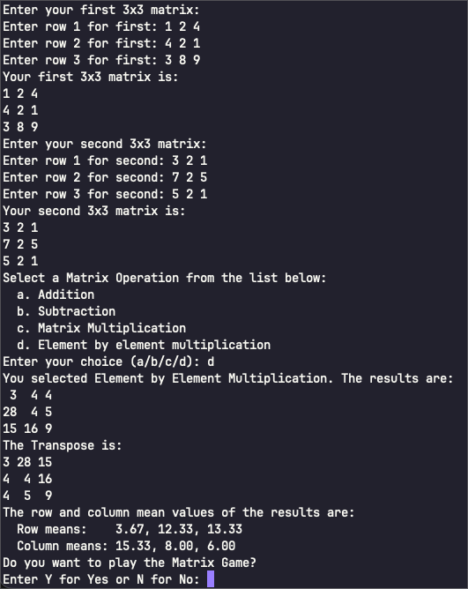

Test Case 26
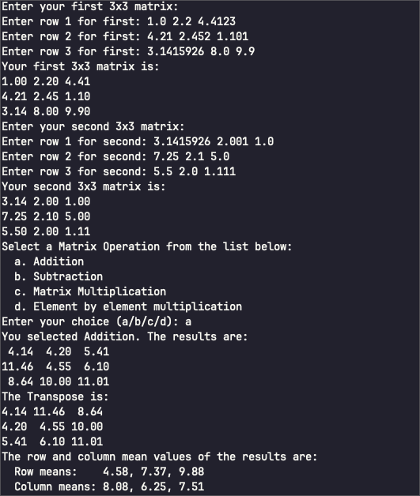

Test Case 27
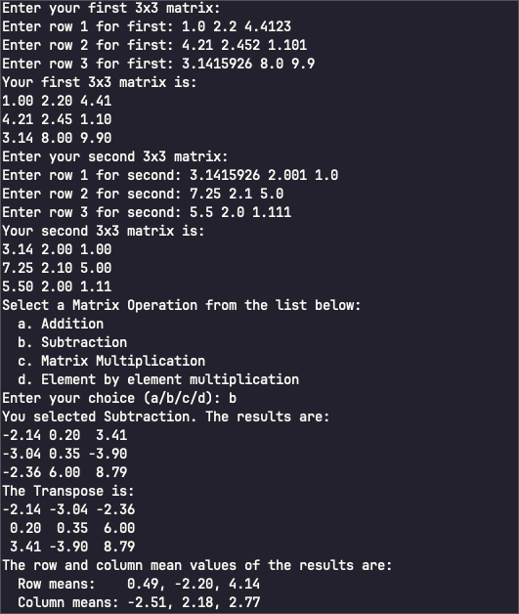

Test Case 28
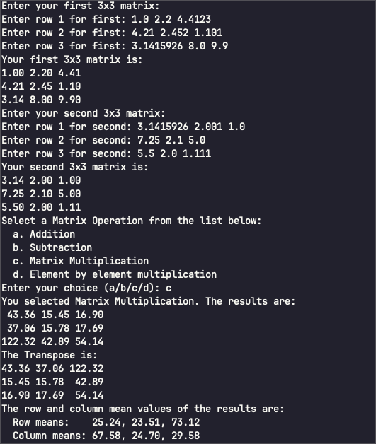

Test Case 29
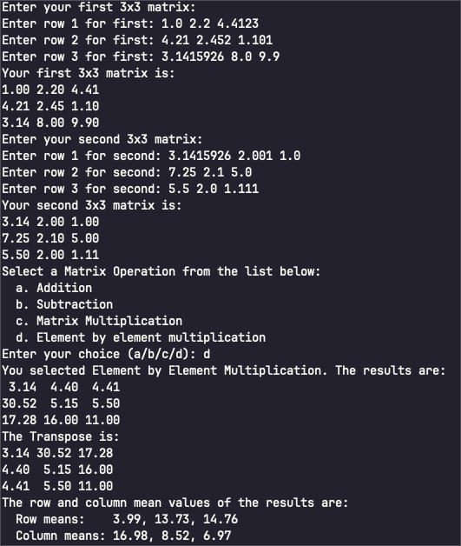

Pylint Results
Pylint run 1:
λ pylint *.py
************* Module matrix_game
matrix_game.py:181:0: C0301: Line too long (115/100) (line-too-long)
matrix_game.py:182:0: C0301: Line too long (114/100) (line-too-long)
matrix_game.py:8:0: E0401: Unable to import 'numpy' (import-error)
matrix_game.py:9:0: E0401: Unable to import 'pandas' (import-error)
-----------------------------------
Your code has been rated at 8.89/10
Pylint run 2 (I forgot to souce my virtual environment for the first run):
λ pylint *.py
************* Module matrix_game
matrix_game.py:181:0: C0301: Line too long (115/100) (line-too-long)
matrix_game.py:182:0: C0301: Line too long (114/100) (line-too-long)
------------------------------------------------------------------
Your code has been rated at 9.81/10 (previous run: 8.89/10, +0.93)
Pylint run 3:
λ pylint *.py
-------------------------------------------------------------------
Your code has been rated at 10.00/10 (previous run: 9.81/10, +0.19)

